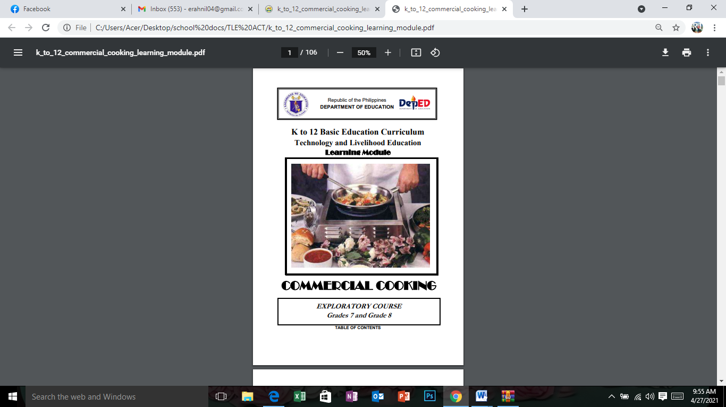

Fourth Grading

**Definition of Terms**

**Cleaning** a physical removal of visible soil and food.

**Disinfectant** a substance used to destroy germs and diseases

**Exterminate** to destroy totally

**Filth** anything that is dirty

**Grates** frames of iron bars for holding fuel while it burns

**Infestation** the state of being infested as with parasites or vermin

**Kitchen** a room especially set apart and containing the necessary utensils for cooking food.

**Parts per million (PPM)** is commonly used as a measure of small levels of pollutants in air, water, body fluids, etc. Parts per million is the mass ratio between the pollutant component and the solution. Usually describes the concentration of something in water or soil. One ppm is equivalent to 1 milligram of something per liter of water (mg/l) or 1 milligram of something per kilogram soil (mg/kg).

**Pedestal** a base or support

**Sanitizer** a chemical agent used for cleansing and sanitizing surfaces and equipment.

**Sanitizing** process of reducing number of harmful organisms to safe level on food contact services.

**Stack** a case compose of several rows of shelves.

**Evaluation**

Instruction: Identify the words that best describe the following statements.

1. It is commonly used as a measure of small levels of pollutants in air, water, body fluids, etc.
2. It is the state of being infested as with parasites or vermin.
3. It is a process of reducing number of harmful organisms to safe level on food contact services.
4. It means to destroy totally.
5. It is a base or support.
6. It refers to the physical removal of visible soil and food
7. It refers to the room which is especially set apart and containing the necessary utensils for cooking food.

1. It refers to a case compose of several rows of shelves.

1. It refers to anything that is dirty.
2. It refers to a substance used to destroy germs and diseases.

ATTENDANCE 4/28/2021

MARSTTHIE, CRIZTEL, JAMES, PRINCESS

